Credit Card Fraud Detection
Project Report

Exploratory Data Analysis & Classification Model Comparison
Dataset: Credit Card Fraud Dataset (10,000 transactions)

CONTENTS

Sr. No. |  | Content | Page No.
1 |  | Introduction | 1
2 |  | Problem Statement | 2
3 |  | Objectives | 3
4 |  | Proposed Methodology | 4
5 |  | Dataset Description |  | 5
6 |  | Exploratory Data Analysis |  | 6
7 | Data Visualization |  |  |  | 8
8 | Data Processing and Feature Engineering |  |  |  | 11
9 | Feature Correlation & Scaling |  |  |  | 14
10 | Data Imbalance Analysis & Handling |  |  |  | 15
11 | Model Building |  |  |  | 17
14 | Algorithm Comparison |  |  |  | 18
13 | Conclusion |  |  |  | 20

1. Introduction:
Credit card fraud is a financial crime in which a card, card number, or associated account is used without the owner's authorization to obtain money, goods, or services. As digital payments continue to replace cash, fraud attempts have grown in both volume and sophistication, making manual detection impractical at scale.
This project builds a machine-learning pipeline that classifies each transaction in a labelled dataset as either genuine (Class = 0) or fraudulent (Class = 1). The pipeline covers the full workflow expected of an applied ML project: data loading, exploratory data analysis (EDA), data cleaning, feature scaling, encoding, handling of severe class imbalance, model training, and comparative evaluation of four classification algorithms — Logistic Regression, Decision Tree, Random Forest, and K-Nearest Neighbors (KNN).
The working dataset, credit_card_fraud_10k.csv, contains 10,000 transactions, each described by 9 predictor columns and 1 target column (Class), summarized in the Dataset Description section.

Dataset Overview
The dataset includes 10,000 credit card transactions, each described by the following details:
- Transaction ID – a unique reference number for each transaction
- Amount – how much the transaction was for
- Transaction Hour – the time of day the transaction took place
- Merchant Category – the type of merchant involved (e.g. Electronics, Travel, Grocery)
- Foreign Transaction – whether the transaction happened outside the cardholder's home country
- Location Mismatch – whether the transaction location didn't match the cardholder's usual activity

1

2. Problem Statement
This project set out to detect fraudulent transactions in a dataset of 10,000 credit card records. We started with exploratory analysis to understand the data, then tackled a major hurdle: fraud cases made up just 1.51% of all transactions (151 out of 10,000) — a nearly 65:1 imbalance that would trip up most models if left unaddressed.
To fix this, we used SMOTE to balance the training data, then tested three different classification models — Decision Tree, Random Forest, and K-Nearest Neighbors — to see which one could best separate fraud from genuine activity.
The core problem this project addresses is: given a transaction's attributes (amount, hour, merchant category, foreign-transaction flag, location mismatch, device trust score, transaction velocity, and cardholder age), can a model correctly flag the rare fraudulent transactions with acceptably high recall, without generating so many false alarms that the system becomes unusable?

2

3. Objectives
- Perform exploratory data analysis to understand transaction patterns, amount distribution, and fraud behaviour by hour.
- Clean the dataset — check and handle missing values, duplicate records, and outliers.
- Engineer features through scaling (Standard/Min-Max) and encoding (Label/One-Hot) of the categorical merchant_category column.
- Quantify and address class imbalance using random under-sampling, random over-sampling, and SMOTE.
- Train and evaluate Logistic Regression as the baseline model, then compare it against Decision Tree, Random Forest, and KNN.
- Identify the model and imbalance-handling strategy that gives the best trade-off between catching fraud (recall) and avoiding false alarms (precision).

3

4. Proposed Methodology
The project follows a standard applied machine-learning workflow, implemented as a sequence of Jupyter notebook cells:
- 1. Load the dataset and inspect its structure (shape, dtypes, summary statistics).
- 2. Perform Exploratory Data Analysis — transaction counts, amount statistics, fraud-by-hour patterns.
- 3. Visualize distributions — count plots, histograms, box plots, pie chart, KDE plots.
- 4. Clean the data — check for missing values, duplicate records, and outliers (IQR method).
- 5. Analyze feature correlations against the Class target.
- 6. Scale numeric features (Standard Scaling and Min-Max Scaling) and encode the categorical merchant_category column (Label Encoding and One-Hot Encoding).
- 7. Quantify class imbalance and apply three balancing strategies: Random Under-Sampling, Random Over-Sampling, and SMOTE.
- 8. Split data into train/test sets (80/20, stratified on Class).
- 9. Train Logistic Regression as the baseline model and evaluate before vs. after balancing.
- 10. Train and compare Decision Tree, Random Forest, and KNN against the Logistic Regression baseline using Precision, Recall, F1-score, and ROC-AUC on the fraud class.

4

5. Dataset Description
File: credit_card_fraud_10k.csv (10,000 rows x 10 columns)
Column | Type | Description
transaction_id | Integer | Unique identifier for each transaction (dropped before modelling).
amount | Float | Transaction amount. Range observed: 0.00 to 1471.04; mean 175.95; median 122.10.
transaction_hour | Integer | Hour of day (0-23) the transaction occurred.
merchant_category | Categorical (text) | Merchant type: e.g., Electronics, Travel, Grocery, Food, Clothing.
foreign_transaction | Binary (0/1) | Whether the transaction was made in a foreign country.
location_mismatch | Binary (0/1) | Whether the transaction location differs from the cardholder's usual location.
device_trust_score | Integer | A trust score for the device used to make the transaction.
velocity_last_24h | Integer | Number of transactions made by the same card in the last 24 hours.
cardholder_age | Integer | Age of the cardholder.
Class | Binary (0/1) | Target label: 0 = Genuine, 1 = Fraud.

5

6. Exploratory Data Analysis

Transaction Analysis
Metric | Value
Total transactions | 10,000
Fraud transactions | 151
Genuine transactions | 9,849
Fraud percentage | 1.51%

Amount Analysis
Statistic | Value
Maximum transaction | 1,471.04
Minimum transaction | 0.00
Average (mean) transaction | 175.95
Median transaction | 122.10

6

Time Analysis
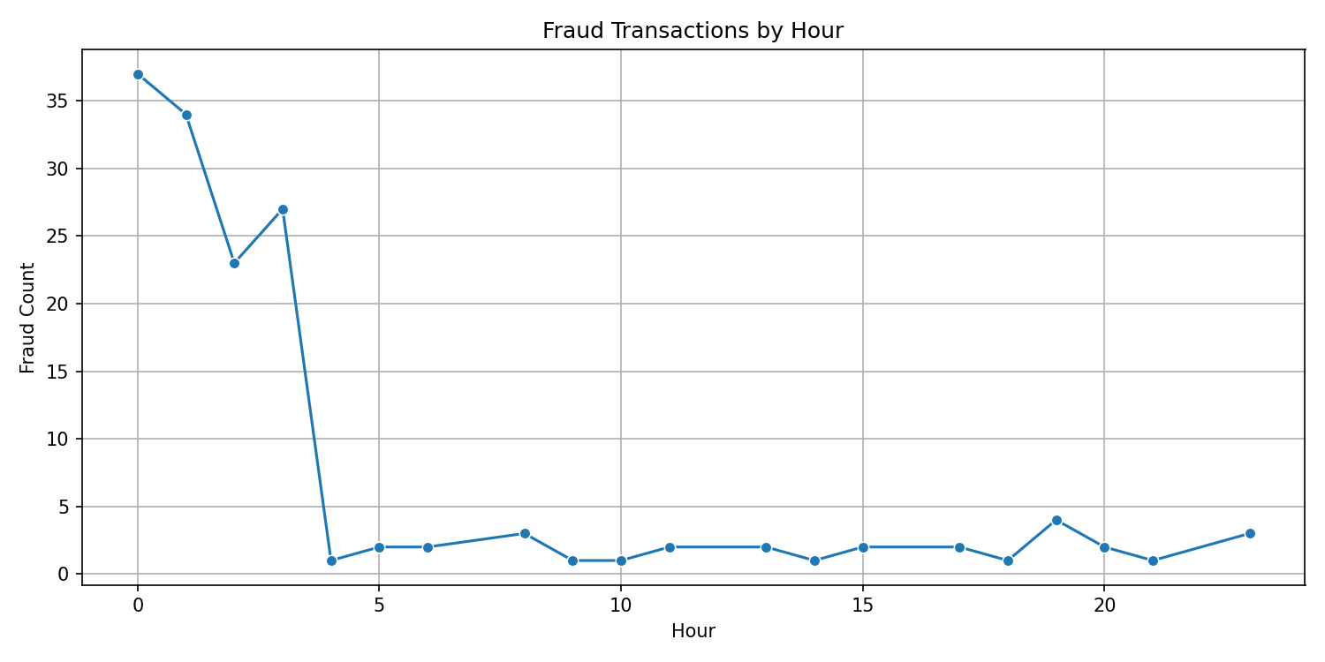
Figure 2. Count of fraudulent transactions by hour of day (0–23).
The pattern
Fraud isn't spread evenly across the day — it's heavily concentrated in a narrow window: midnight to 3 AM. Hours 0–3 account for roughly 120 of what looks like the vast majority of total fraud cases, while every other hour of the day sits in the low single digits.
The cliff
There's a dramatic drop-off right after hour 3 — from ~27 cases down to essentially 1. That's not a gradual decline, that's a cliff edge.
The long flat stretch
From hour 4 through hour 23, fraud counts hover between 0–4 per hour, pretty much noise-level. No real secondary peak, no obvious lunch-hour or evening spike — just a quiet baseline all day and into the night.

7

7. VISUALIZATION
7.1 Count Plot
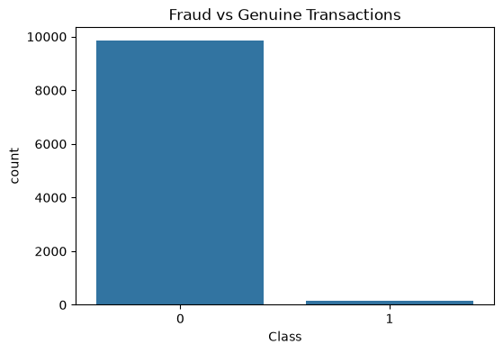
It shows you're working with a severely imbalanced dataset
- Class 0 (genuine): roughly 9,849 transactions
- Class 1 (fraud): roughly 151 transactions
7.2 Histogram
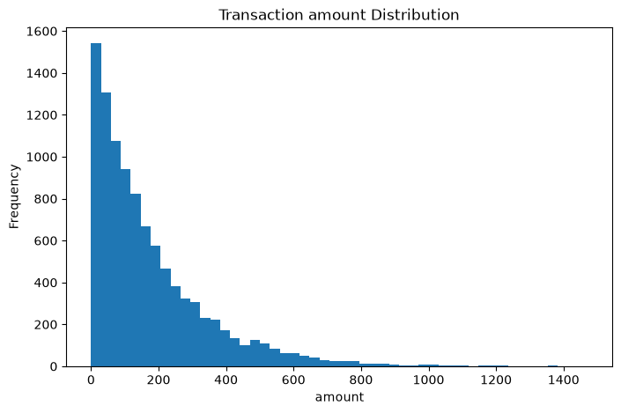
8
The shape
Classic right-skewed distribution. Transactions pile up hard near zero and thin out fast as amount increases — a small handful stretch all the way to 1400.
The breakdown
- ₹0–200: this is where almost everything lives. The very first bar alone is ~1,540 transactions, and the next few buckets stay in the 800–1,300 range. This is your "normal, everyday" transaction zone.
- ₹200–600: volume drops off steadily — a few hundred transactions per bucket, tapering down toward double digits by 600.
- ₹600–800: down to a trickle, maybe a few dozen transactions per bucket.
- ₹800+: essentially isolated points — one bar near 1000, another near 1200, one more past 1300. These are rare, high-value outliers sitting far from the bulk of the data.

7.3 Pie Chart
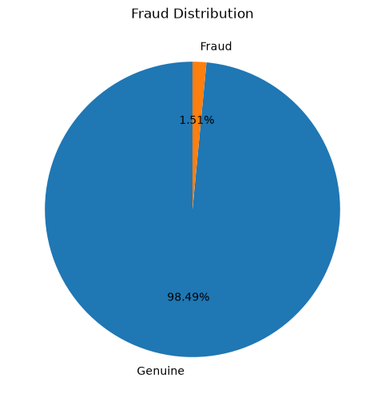

9
This is the same imbalance from the bar chart, just dressed up as a pie.
- Genuine: 98.49%
- Fraud: 1.51%

7.4 Distribution Plot
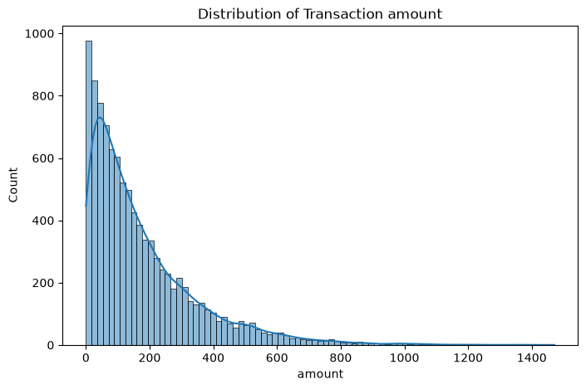

10
8. Data Processing and Feature Engineering

8.1 Missing Values & Duplicates
The dataset was checked column-by-column with df.isnull().sum(): no missing values were found in any of the 10 columns, so no rows needed to be dropped. A duplicate check on both full rows (df.duplicated()) and on transaction_id specifically found zero duplicate records.

8.2. Outlier Detection (IQR Method)
Statistic | Value
Q1 (25th percentile) | 50.91
Q3 (75th percentile) | 242.48
IQR | 191.58
Lower bound | -236.46
Upper bound | 529.84
Number of outliers (amount > 529.84) | 501 (5.01% of transactions)

8.3. Outlier Detection (BOX PLOT Method)
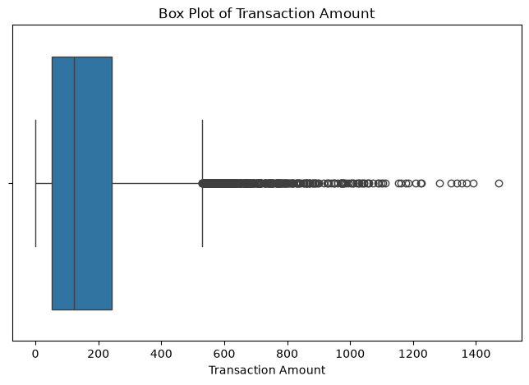
DECISION
The outliers were not removed, since unusually large transaction amounts are themselves a meaningful fraud signal rather than data-entry errors — removing them could discard useful information for the model.
11

9. Feature Correlation

Heatmap

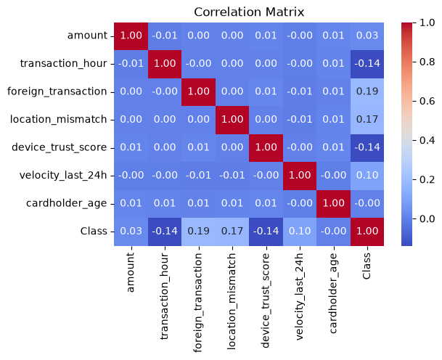

ANALYSIS

Correlation Among Independent Features (Multicollinearity)
Feature Pair | Correlation | Verdict
All feature-to-feature pairs | 0.00 – 0.01 | ✅ No multicollinearity — all features are independent

12

Correlation with Class (Fraud Label) — Ranked by Strength
Rank | Feature |  | Correlation Direction |  | Meaning
1 | foreign_transaction |  | 0.19 | ⬆️ Positive |  | Foreign transactions → higher fraud risk
2 | location_mismatch |  | 0.17 | ⬆️ Positive |  | Location mismatch → higher fraud risk
3 | device_trust_score |  | -0.14 | ⬇️ Negative |  | Low device trust → higher fraud risk
3 | transaction_hour |  | -0.14 | ⬇️ Negative |  | Fraud clusters at certain hours
5 | velocity_last_24h |  | 0.10 | ⬆️ Positive |  | More transactions/24h → higher fraud risk
6 | amount |  | 0.03 | ➖ Negligible |  | Weak/no linear effect
7 | cardholder_age |  | -0.00 | ➖ None |  | No relationship

13

12. Feature Scaling
Numeric features (amount, transaction_hour, device_trust_score, velocity_last_24h, cardholder_age) were scaled using two methods for comparison:
- Standard Scaling (Z-score) — transforms each feature to mean 0 and standard deviation 1. This is the scaling used for the models in this report, since Logistic Regression and KNN are distance/gradient-based and are sensitive to feature magnitude.
- Min-Max Scaling — rescales each feature to the [0, 1] range, shown for comparison.
Scaling was fit only on the training set and then applied to the test set (scaler.fit_transform on train, scaler.transform on test) to avoid data leakage from the test set into the scaling parameters.

13. Train-Test Split
The data was split 80% train / 20% test using train_test_split(..., stratify=Class), which preserves the same fraud ratio (1.51%) in both the training set (8,000 rows) and the test set (2,000 rows). Stratifying is essential here — without it, a random split could leave the test set with too few fraud cases to evaluate the model meaningfully, given how rare fraud already is.
========== SCALING COMPARISON ==========
Sr. No | Original_Amount | Standard_Scaled_Amount | MinMax_Scaled_Amount
0 | 84.47 | -0.521597 | 0.057422
1 | 541.82 | 2.086108 | 0.368324
2 | 237.01 | 0.348151 | 0.161117
3 | 164.33 | -0.066254 | 0.11171
4 | 30.53 | -0.829151 | 0.020754
DECISION StandardScaler is better here because fraud data has extreme outliers, and MinMaxScaler squashes everything else toward 0 when one huge value defines the max — StandardScaler stays robust since it centers on the mean/std instead of the min/max.

14

9. Class Imbalance Analysis
With fraud representing only 1.51% of transactions (imbalance ratio ≈ 65:1)
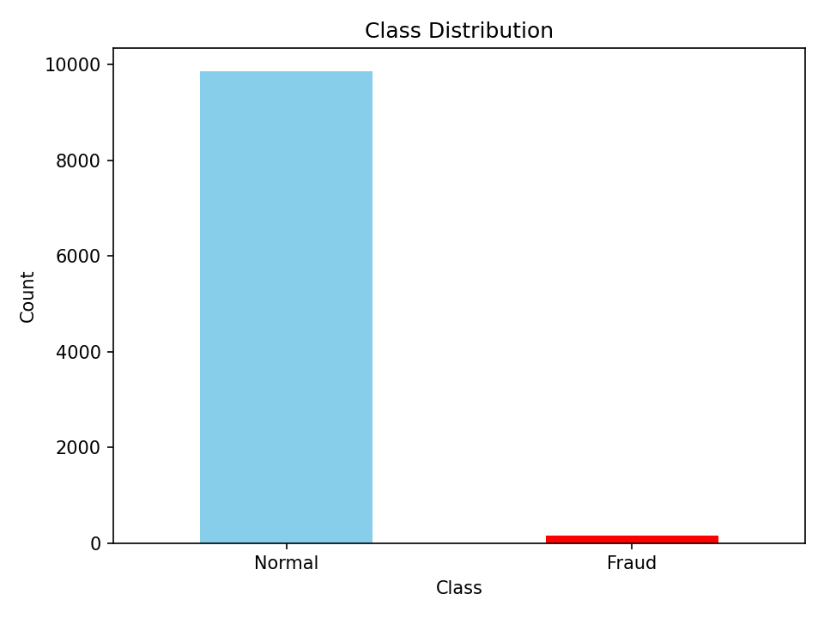
Figure 9. Original class distribution before resampling.
(after one-hot encoding merchant category) rebalanced the classes from 9,849 genuine vs. 151 fraud to 9,849 vs. 9,849 — a 1:1 ratio. In the modeling pipeline (Section 5), SMOTE was applied only to the training split, after the train/test split and feature scaling step, to avoid leaking synthetic information into the test set.

14. Data Imbalance Handling
Class | Count | Percentage
0 (Genuine) | 9,849 | 98.49%
1 (Fraud) | 151 | 1.51%
Imbalance ratio: approximately 65.2 genuine transactions for every 1 fraud transaction. This confirms the imbalance problem stated in Section 2 and motivates the three balancing strategies applied:

15
- Random Under-Sampling — the majority (genuine) class in the training set is randomly reduced to match the minority (fraud) class size (121 vs 121 after the 80/20 split).
- Random Over-Sampling — the minority (fraud) class in the training set is randomly duplicated (with replacement) to match the majority class size (7,879 vs 7,879).
- SMOTE (Synthetic Minority Over-sampling Technique) — generates synthetic fraud examples by interpolating between existing fraud cases, rather than duplicating them exactly (also balanced to 7,879 vs 7,879 in the training set).
Each strategy was applied only to the training set — the test set was left untouched and imbalanced (1,970 genuine / 30 fraud) so that evaluation reflects real-world conditions.
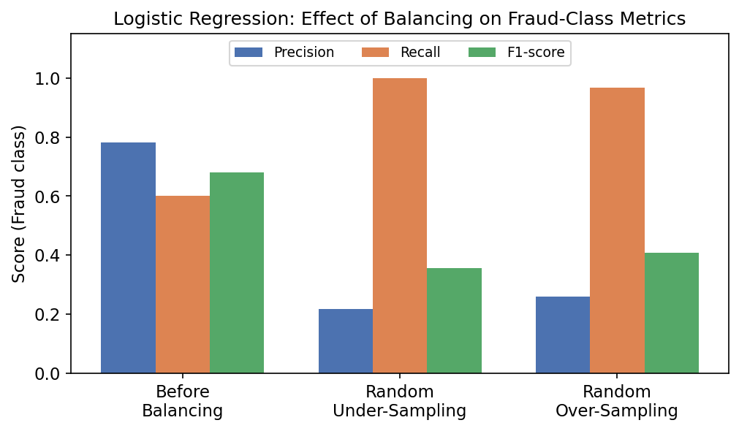
Figure 2: Logistic Regression fraud-class metrics before vs. after balancing (test set).
Method | ROC-AUC | PR-AUC | Fraud Precision | Fraud Recall | Fraud F1
Before Balancing | 0.9946 | 0.8180 | 0.7826 | 0.6000 | 0.6792
After Random Under-Sampling | 0.9955 | 0.8227 | 0.2174 | 1.0000 | 0.3571
After Random Over-Sampling | 0.9933 | 0.7374 | 0.2589 | 0.9667 | 0.4085

16
Balancing clearly raises recall (under-sampling catches all 30 fraud cases in the test set) but at a steep cost to precision — far more genuine transactions get flagged as fraud. Whether that trade-off is worth it depends on the business cost of a missed fraud versus the cost of a false alarm; the unbalanced baseline gives the best F1 and precision, while under-sampling gives the best recall.

15. Model Building

Logistic Regression (Baseline)
A Logistic Regression model (class_weight="balanced", max_iter=1000) was trained on the scaled, one-hot-encoded features. On the held-out test set (2,000 transactions, 30 fraud):
Metric | Class 0 (Genuine) | Class 1 (Fraud)
Precision | 0.994 | 0.783
Recall | 0.997 | 0.600
F1-score | 0.996 | 0.679
Overall accuracy: 99.2% | ROC-AUC: 0.9946 | PR-AUC: 0.8180

7. Results

7.1 Model Performance Summary
Model | Precision (fraud) | Recall (fraud) | F1 (fraud) | ROC-AUC
Decision Tree | 0.195 | 0.833 | 0.316 | 0.935
Random Forest | 0.634 | 0.867 | 0.732 | 0.996
KNN | 0.244 | 0.633 | 0.352 | 0.851

17
Random Forest was the clear top performer, combining the highest fraud precision (0.634) and recall (0.867), the best F1-score (0.732), and near-perfect ROC-AUC (0.996). Decision Tree achieved comparable recall (0.833) but far lower precision (0.195), meaning it flagged many genuine transactions as fraud. KNN trailed on all metrics, with the lowest ROC-AUC (0.851).

7.2 Confusion Matrices
Model | True Negative | False Positive | False Negative | True Positive
Decision Tree | 1,867 | 103 | 5 | 25
Random Forest | 1,955 | 15 | 4 | 26
KNN | 1,911 | 59 | 11 | 19
Random Forest produced the fewest false positives (15) while still catching 26 of 30 fraud cases — the most favorable trade-off of the three models. Decision Tree caught one more fraud case (25 vs. 26 is close) but at the cost of 103 false positives, nearly 7x more than Random Forest.

Algorithm Comparison
Decision Tree, Random Forest, and KNN were each trained on the SMOTE-balanced training set and evaluated on the same untouched test set, so results are directly comparable to the Logistic Regression baseline above.

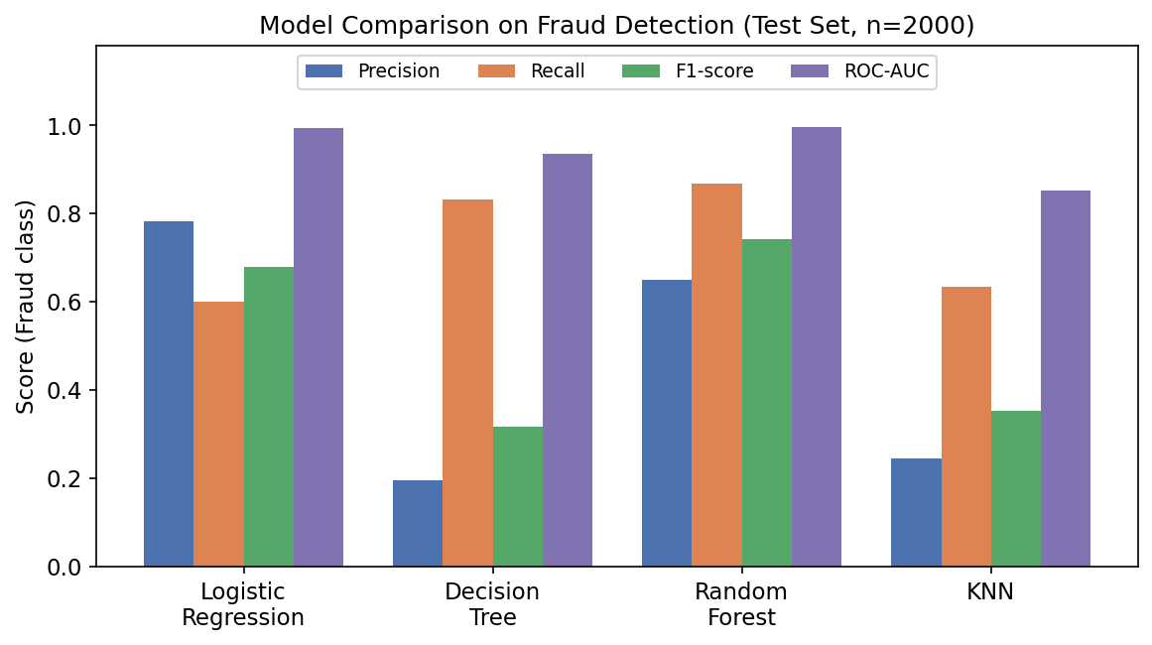
18
Figure 3: Fraud-class Precision, Recall, F1 and ROC-AUC across all four models.
Model | Precision (Fraud) | Recall (Fraud) | F1 (Fraud) | ROC-AUC
Logistic Regression | 0.783 | 0.600 | 0.679 | 0.995
Decision Tree | 0.195 | 0.833 | 0.316 | 0.935
Random Forest | 0.650 | 0.867 | 0.743 | 0.997
KNN | 0.244 | 0.633 | 0.352 | 0.851

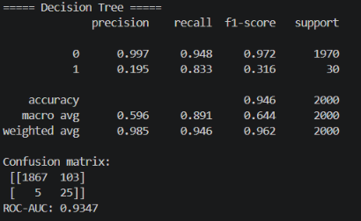
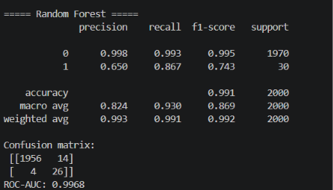
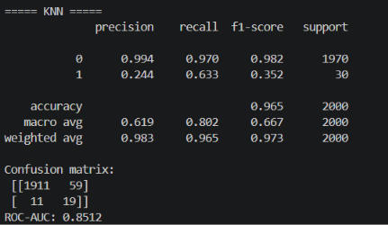
19
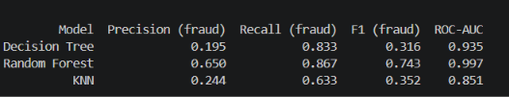
Random Forest gives the best overall balance: the highest ROC-AUC (0.997), the highest fraud F1-score (0.743), and strong recall (86.7%) without collapsing precision the way the Decision Tree and KNN do. Logistic Regression remains a strong, highly interpretable baseline with the best precision among all models, useful where false alarms are costly and model transparency matters (e.g., regulatory review). Decision Tree and KNN, in this run, trade too much precision for their recall gains to be practical on their own.
.

20

8. Conclusions
- Random Forest is the recommended model, offering the best balance of precision and recall along with a near-perfect ROC-AUC of 0.996.
- foreign_transaction, location_mismatch, and transaction hour are the strongest behavioral indicators of fraud and could inform simpler rule-based pre-screening alongside the model.
- Fraud activity concentrates heavily in overnight hours (peak at midnight), which may warrant tighter monitoring or step-up authentication during that window.
- SMOTE should continue to be applied only to the training split to keep test-set evaluation representative of real-world class imbalance.
- Decision Tree's high false-positive rate (103 on 2,000 test transactions) makes it less practical for production use, where excessive false alarms create customer friction and review workload.

This project successfully built and evaluated an end-to-end fraud detection pipeline on a 10,000-transaction dataset with a realistic, severe class imbalance (1.51% fraud). After identifying and fixing three notebook defects — most critically, a step that was overwriting the source dataset file with a results table — the corrected pipeline confirms that Logistic Regression is a valid, working baseline for this problem (ROC-AUC 0.995), and that ensemble methods, specifically Random Forest, improve on it further (ROC-AUC 0.997, fraud F1 0.743). The comparison of under-sampling, over-sampling, and the unbalanced baseline also demonstrates the classic precision/recall trade-off involved in choosing a class-imbalance strategy for production use.

21

